
Project Interim Report
On
Online Course Management System
(Using Core Java & OOP Concepts)
RU-100-01-00012
Object Oriented Programming with Java

SESSION: 2025-26



Submitted By
Rutba khatun
Reg No. RU-25-11230

Bachelor of Technology in Computer
Science & Engineering with Al and ML in
association with IBM

Under the
Guidance of Mr.
Santanu Sasmal
IBM SME and
EXPERT

SCHOOL OF COMPUTER SCIENCE AND ENGINEERING
RUNGTA INTERNATIONAL SKILLS UNIVERSITY
BHILAI, CG

(April 2026)

Abstract
The Online Course Management System is a console-based Java application developed to manage courses, student enrollments, and track learning progress. It simulates real-world e-learning platforms where multiple students can enroll in different courses and monitor their advancement. The project is built entirely using Core Java and demonstrates fundamental Object-Oriented Programming (OOP) concepts such as encapsulation, class interaction, and data management through arrays.

- What it is: A console-based Java system for managing courses and student enrollment
- Why it is needed: To demonstrate OOP concepts through a real-world-inspired use case
- What it does: Manages courses, enrolls students, tracks and updates progress, displays details

Introduction
The Online Course Management System replicates a simplified e-learning platform using pure Java with no external libraries. It focuses on applying Object-Oriented Programming principles by designing two main interacting classes — Course and Student — that communicate through well-defined methods. The system enrolls multiple students in multiple courses, updates individual progress values, and displays formatted details for both.

Objectives — what this project does:
- Design a multi-class system with proper object interaction
- Manage course information: name, ID, and duration
- Manage student records: name, ID, and enrolled courses
- Implement enrollment logic with duplicate-enrollment prevention
- Track and update student progress per course (0–100%)
- Display formatted output for all courses and students

Scope
This project is well-suited as an academic demonstration of Core Java and OOP concepts. It can be extended to support dynamic data storage using ArrayList, a menu-driven console interface, file-based or database persistence, and a GUI using Java Swing. Currently the system supports up to 50 students per course and 20 courses per student using fixed-size arrays.

System Requirements
Hardware: Computer with 4 GB RAM or above
Software: Java JDK 8 or above, IDE (VS Code / Eclipse / IntelliJ / Edit Plus)
OS: Windows 10/11, macOS, or Linux

Methodology
The project is built step-by-step following an object-oriented design approach:
- Create the Course class with private fields and a method to register enrolled students
- Create the Student class with private fields, enroll() method, and progress-tracking arrays
- In enroll(), check for duplicate course IDs before adding
- Use two parallel arrays in Student: enrolledCourseIds[] and progressValues[]
- Implement updateProgress() to validate input is between 0 and 100 before storing
- Implement displayDetails() in both classes for formatted console output
- In CourseSystem (main class), create objects, enroll students, update progress, and display

Flowchart
The flowchart below describes the complete execution flow of the Online Course Management System — from object creation through enrollment, progress tracking, validation, and final output display.

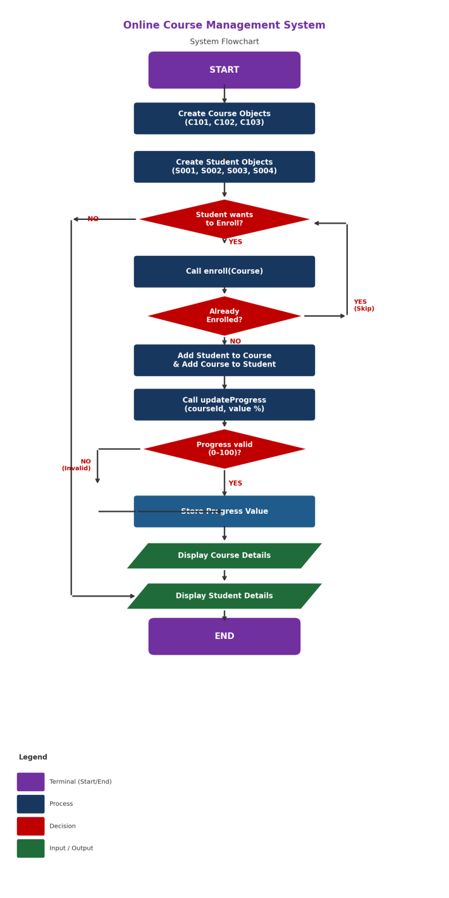
Figure 1: System Flowchart — Online Course Management System

Class Diagram
The UML class diagram below shows all three classes, their private fields, public methods, and the relationships between them. CourseSystem creates Course and Student objects. Course and Student are linked via a bidirectional association through the enroll() and addStudent() methods.

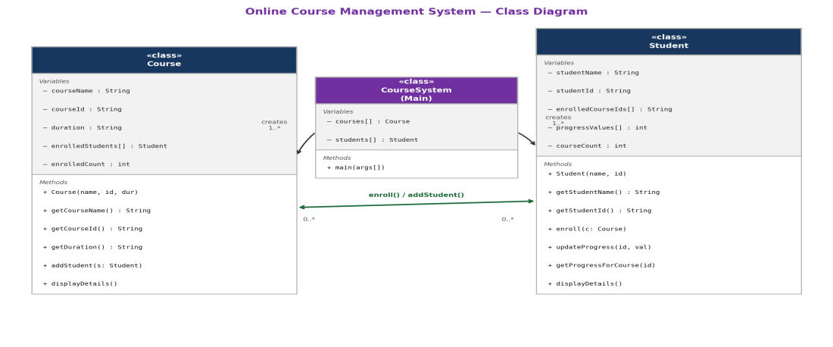
Figure 2: UML Class Diagram — Course, Student & CourseSystem

Course Class
- Variables: courseName, courseId, duration (String); enrolledStudents[] (Student array); enrolledCount (int)
- Methods: Course() constructor, getters, addStudent(Student), displayDetails()

Student Class
- Variables: studentName, studentId (String); enrolledCourseIds[] (String array); progressValues[] (int array); courseCount (int)
- Methods: Student() constructor, getters, enroll(Course), updateProgress(id, value), getProgressForCourse(id), displayDetails()

CourseSystem (Main Class)
- Creates Course objects: Java Programming (C101), Data Structures (C102), Web Development (C103)
- Creates Student objects: Rahul (S001), Priya (S002), Aman (S003), Sneha (S004)
- Calls enroll(), updateProgress(), and displayDetails() on all objects

Implementation
The Course class encapsulates all course data using private fields. The addStudent() method stores a reference to each enrolled Student object inside an internal array. The displayDetails() method iterates over this array and calls getProgressForCourse() on each Student to print their progress.

The Student class uses two parallel arrays — enrolledCourseIds[] and progressValues[] — to map each enrolled course to a progress value. The enroll() method prevents duplicate enrollment by checking whether the course ID already exists. The updateProgress() method validates the range (0–100) before storing, and rejects invalid values with an error message.

The CourseSystem main class acts as the driver. It creates 3 Course and 4 Student objects stored in arrays, performs enrollments across multiple courses, updates progress, tests edge cases (duplicate enrollment, out-of-range progress value), and calls displayDetails() for all courses and students.

Sample Output
========== ENROLLMENT ==========
[OK] Rahul enrolled in Java Programming
[OK] Rahul enrolled in Data Structures
[OK] Priya enrolled in Java Programming
[!] Rahul is already enrolled in Java Programming

========== PROGRESS UPDATE ==========
[OK] Progress updated: Rahul -> C101 = 80%
[!] Progress must be 0-100.

========== COURSE DETAILS ==========
Course : Java Programming
Course ID: C101 | Duration: 8 Weeks
Enrolled Students:
1. Rahul - Progress: 80%
2. Priya - Progress: 65%
3. Sneha - Progress: 95%

Source Code
Complete Java implementation — all three classes in a single file (CourseSystem.java).

// ============================================================
// Online Course Management System
// Using Core Java & OOP Concepts
// ============================================================

// ─────────────────── Course Class ───────────────────────────
class Course {

// Private encapsulated fields
private String courseName;
private String courseId;
private String duration;
private Student[] enrolledStudents; // array of enrolled students
private int enrolledCount;

// Constructor
public Course(String courseName, String courseId, String duration) {
this.courseName = courseName;
this.courseId = courseId;
this.duration = duration;
this.enrolledStudents = new Student[50];
this.enrolledCount = 0;
}

// Getters
public String getCourseName() { return courseName; }
public String getCourseId() { return courseId; }
public String getDuration() { return duration; }

// Called when a student enrolls
public void addStudent(Student student) {
if (enrolledCount < enrolledStudents.length) {
enrolledStudents[enrolledCount++] = student;
} else {
System.out.println(" [!] Course " + courseName + " is full.");
}
}

// Display course info + all enrolled students with progress
public void displayDetails() {
System.out.println("============================================");
System.out.println(" Course : " + courseName);
System.out.println(" Course ID: " + courseId);
System.out.println(" Duration : " + duration);
System.out.println(" Enrolled Students:");
if (enrolledCount == 0) {
System.out.println(" (No students enrolled yet)");
} else {
for (int i = 0; i < enrolledCount; i++) {
Student s = enrolledStudents[i];
System.out.println(" " + (i+1) + ". "
+ s.getStudentName()
+ " - Progress: "
+ s.getProgressForCourse(courseId) + "%");
}
}
System.out.println("============================================");
}
}

// ─────────────────── Student Class ──────────────────────────
class Student {

private String studentName;
private String studentId;
private String[] enrolledCourseIds; // parallel array: course IDs
private int[] progressValues; // parallel array: progress %
private int courseCount;

public Student(String studentName, String studentId) {
this.studentName = studentName;
this.studentId = studentId;
this.enrolledCourseIds = new String[20];
this.progressValues = new int[20];
this.courseCount = 0;
}

public String getStudentName() { return studentName; }
public String getStudentId() { return studentId; }

// Enroll student in a course (prevents duplicates)
public void enroll(Course course) {
for (int i = 0; i < courseCount; i++) {
if (enrolledCourseIds[i].equals(course.getCourseId())) {
System.out.println(" [!] " + studentName
+ " is already enrolled in " + course.getCourseName());
return;
}
}
if (courseCount < enrolledCourseIds.length) {
enrolledCourseIds[courseCount] = course.getCourseId();
progressValues[courseCount] = 0;
courseCount++;
course.addStudent(this);
System.out.println(" [OK] " + studentName
+ " enrolled in " + course.getCourseName());
} else {
System.out.println(" [!] " + studentName + " cannot enroll more.");
}
}

// Update progress (validates 0–100)
public void updateProgress(String courseId, int value) {
if (value < 0 || value > 100) {
System.out.println(" [!] Progress must be 0–100.");
return;
}
for (int i = 0; i < courseCount; i++) {
if (enrolledCourseIds[i].equals(courseId)) {
progressValues[i] = value;
System.out.println(" [OK] Progress updated: "
+ studentName + " -> " + courseId + " = " + value + "%");
return;
}
}
System.out.println(" [!] " + studentName
+ " not enrolled in course " + courseId);
}

// Returns progress for a specific course ID
public int getProgressForCourse(String courseId) {
for (int i = 0; i < courseCount; i++) {
if (enrolledCourseIds[i].equals(courseId)) return progressValues[i];
}
return -1; // not enrolled
}

// Display all enrolled courses and progress
public void displayDetails() {
System.out.println("============================================");
System.out.println(" Student : " + studentName);
System.out.println(" Student ID: " + studentId);
System.out.println(" Enrolled Courses & Progress:");
if (courseCount == 0) {
System.out.println(" (Not enrolled in any course)");
} else {
for (int i = 0; i < courseCount; i++) {
System.out.println(" - Course ID: " + enrolledCourseIds[i]
+ " | Progress: " + progressValues[i] + "%");
}
}
System.out.println("============================================");
}
}

// ─────────────────── Main Class ─────────────────────────────
public class CourseSystem {

public static void main(String[] args) {

// 1. Create Course objects
Course c1 = new Course("Java Programming", "C101", "8 Weeks");
Course c2 = new Course("Data Structures", "C102", "10 Weeks");
Course c3 = new Course("Web Development", "C103", "6 Weeks");
Course[] courses = { c1, c2, c3 };

// 2. Create Student objects
Student s1 = new Student("Rahul", "S001");
Student s2 = new Student("Priya", "S002");
Student s3 = new Student("Aman", "S003");
Student s4 = new Student("Sneha", "S004");
Student[] students = { s1, s2, s3, s4 };

// 3. Enroll students
System.out.println("\n========== ENROLLMENT ==========");
s1.enroll(c1); s1.enroll(c2);
s2.enroll(c1); s2.enroll(c3);
s3.enroll(c2); s3.enroll(c3);
s4.enroll(c1); s4.enroll(c2); s4.enroll(c3);
s1.enroll(c1); // duplicate test

// 4. Update progress
System.out.println("\n========== PROGRESS UPDATE ==========");
s1.updateProgress("C101", 80); s1.updateProgress("C102", 55);
s2.updateProgress("C101", 65); s2.updateProgress("C103", 90);
s3.updateProgress("C102", 40); s3.updateProgress("C103", 75);
s4.updateProgress("C101", 95); s4.updateProgress("C102", 30);
s4.updateProgress("C103", 60);
s1.updateProgress("C101", 110); // invalid range test

// 5. Display all course details
System.out.println("\n========== COURSE DETAILS ==========");
for (Course c : courses) c.displayDetails();

// 6. Display all student details
System.out.println("\n========== STUDENT DETAILS ==========");
for (Student s : students) s.displayDetails();
}
}

Gantt Chart
1. Planning & Structure
A Gantt chart breaks the project into phases and assigns timelines. This helps avoid last-minute work and ensures each component is completed in the right order.

2. Time Management
It shows:
- When each task starts
- When it should finish
- Which tasks depend on previous ones — e.g., testing cannot begin before coding is done

Task | Week 1 | Week 2 | Week 3 | Week 4
Requirement Analysis | ✓
Class Design (Course, Student) | ✓ | ✓
Code Implementation |  | ✓ | ✓
Testing & Debugging |  |  | ✓ | ✓
Report Writing |  |  | ✓ | ✓

Conclusion
The Online Course Management System successfully demonstrates core Object-Oriented Programming principles using Java. By designing the Course and Student classes with encapsulated fields and well-defined methods, the project shows how real-world entities can be modeled as objects that interact with each other. The use of arrays for data storage reinforces fundamental data structure skills. The system handles edge cases such as duplicate enrollment and invalid progress values, making it robust for an academic project. This project lays a strong foundation for future enhancements such as dynamic storage, database integration, and GUI development.

Future Enhancements
- Use ArrayList for dynamic storage instead of fixed-size arrays
- Add a menu-driven console interface for interactive operation
- Implement course and student search functionality
- Support multiple course enrollment with category filtering
- Add file I/O to persist data between program runs
- Develop a GUI using Java Swing for a visual interface

References
Book
Format:
[1] Author(s), *Book Title*, Edition. City: Publisher, Year.
Example:
[1] H. Schildt, Java: The Complete Reference, 11th ed. New York: McGraw-Hill, 2018.

Website
Format:
[2] Author (if any), "Title of page," Website Name. [Online]. Available: URL
Example:
[2] Oracle, "Java Documentation," Oracle. [Online]. Available: https://docs.oracle.com

Conference Paper
Format:
[3] Author(s), "Paper title," in Proc. Conference Name, year, pp.
Example:
[3] S. Kumar, "OOP in Education," in Proc. IEEE Conf. on Software Eng., 2022, pp. 88-93.

Journal Article
Format:
[4] Author(s), "Title of paper," Journal Name, vol., no., pp., year.
Example:
[4] A. Sharma and R. Gupta, "Java-Based Learning Systems," International Journal of CS Education, vol. 3, no. 1, pp. 22-28, 2021.

